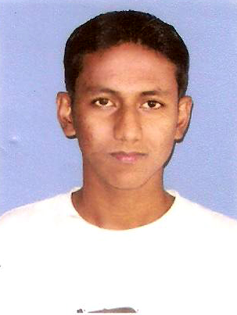
CURRICULUM VITAE

SRI MADHURJYA NAZIR SAIKIA

C/o MR JAGANATH NAZIR
Lahdoigarh Hatibaruah Chariali
P.O. :- Lahdoigarh
P.S :- Teok
Dist:- Jorhat, State:- Assam
Contact No :- (+91)8011141660

CAREER OBJECTIVE:

- To be a professional making qualitative difference through hard work and sheer dedication, to innovate and prove as an asset for the organization.
- To secoure a position where my qualities of a fast learner and the ability to take on new challenges can be used to full effect.

EDUCATIONAL QUALIFICATION

- HSLC form SEBA in 2005 (2nd division with 55.33%)
- HS form AHSEC in 2008 (2nd division with 58.94%)

TECHINCAL QULIFICATION:

- Diploma in Information Technology & Electronics System Maintenance (IT&Esm) from Jorhat I.T.I in 2008 to 2010 (A Grade with 73.84%)
- Computer DCA

PERSONAL SKILLS:

Comprehensive problem solving abilities solving abilities, good verbal and written communication skill, proactive and learning abilities, team facilitator.

PROFESSIONAL EXPERIENCE:

Survey of Dairy D.C.S. formed under NEADS

PERSONAL PROFILE:

Name : Madhurjya Nazir Saikia
Father’s Name : Mr. Jaganath Nazir
Nationality : Indian
Religion : Hinduism
Cast : O.B.C.
Date of Birth : 23-09-1988
Gender : Male
Language Known : Assamese, Hindi and English
Hobbies : Traveling

DECLARATION

I, Sri Madhurjya Nazir Saikia, hereby declare that the particulars given here in are true to the best of my knowledge and belief.

DATE :
PLACE : Jorhat (Madhurjya Nazir Saikia)

